Deleting the Document

**Note:** XML files are already saved in “exercise_files” directory. Use vscode to view files.

To delete documents from the index of Apache Solr, we need to specify the ID’s of the documents to be deleted between the <delete></delete> tags.

<delete>

<id>003</id>

<id>005</id>

<id>004</id>

<id>002</id>

</delete>

Here, this XML code is used to delete the documents with ID’s **003** and **005**. Save this code in a file with the name **delete.xml**.

If you want to delete the documents from the index which belongs to the core named **my_core**, then you can post the **delete.xml** file using the **post** tool, as shown below.

[Hadoop@localhost bin]$ post -c my_core delete.xml

On executing the above command, you will get the following output.

/home/Hadoop/java/bin/java -classpath /home/Hadoop/Solr/dist/Solr-core

6.2.0.jar -Dauto = yes -Dc = my_core -Ddata = files

org.apache.Solr.util.SimplePostTool delete.xml

SimplePostTool version 5.0.0

Posting files to [base] url http://localhost:8983/Solr/my_core/update...

Entering auto mode. File endings considered are

xml,json,jsonl,csv,pdf,doc,docx,ppt,pptx,xls,xlsx,odt,odp,ods,ott,otp,ots,

rtf,htm,html,txt,log

POSTing file delete.xml (application/xml) to [base]

1 files indexed.

COMMITting Solr index changes to http://localhost:8983/Solr/my_core/update...

Time spent: 0:00:00.179

Verification

Visit the homepage of the of Apache Solr web interface and select the core as **my_core**. Try to retrieve all the documents by passing the query “:” in the text area **q** and execute the query. On executing, you can observe that the specified documents are deleted.

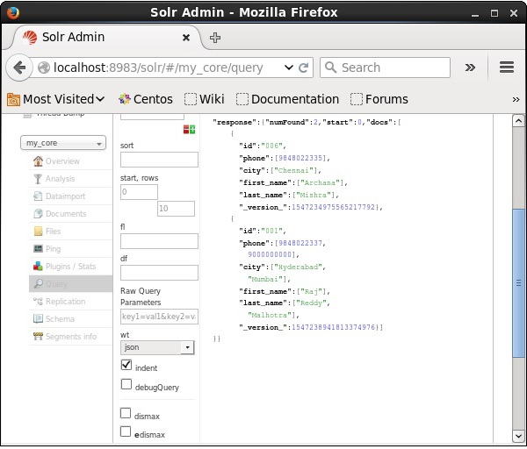

Deleting a Field

Sometimes we need to delete documents based on fields other than ID. For example, we may have to delete the documents where the city is Chennai.

In such cases, you need to specify the name and value of the field within the <query></query> tag pair.

<delete>

<query>city:Chennai</query>

</delete>

Save it as **delete_field.xml** and perform the delete operation on the core named **my_core** using the **post** tool of Solr.

[Hadoop@localhost bin]$ post -c my_core delete_field.xml

On executing the above command, it produces the following output.

/home/Hadoop/java/bin/java -classpath /home/Hadoop/Solr/dist/Solr-core

6.2.0.jar -Dauto = yes -Dc = my_core -Ddata = files

org.apache.Solr.util.SimplePostTool delete_field.xml

SimplePostTool version 5.0.0

Posting files to [base] url http://localhost:8983/Solr/my_core/update...

Entering auto mode. File endings considered are

xml,json,jsonl,csv,pdf,doc,docx,ppt,pptx,xls,xlsx,odt,odp,ods,ott,otp,ots,

rtf,htm,html,txt,log

POSTing file delete_field.xml (application/xml) to [base]

1 files indexed.

COMMITting Solr index changes to http://localhost:8983/Solr/my_core/update...

Time spent: 0:00:00.084

Verification

Visit the homepage of the of Apache Solr web interface and select the core as **my_core**. Try to retrieve all the documents by passing the query “:” in the text area **q** and execute the query. On executing, you can observe that the documents containing the specified field value pair are deleted.

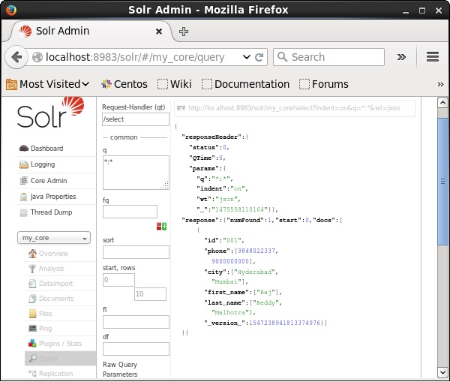

Deleting All Documents

Just like deleting a specific field, if you want to delete all the documents from an index, you just need to pass the symbol “:” between the tags <query></ query>, as shown below.

<delete>

<query>*:*</query>

</delete>

Save it as **delete_all.xml** and perform the delete operation on the core named **my_core** using the **post** tool of Solr.

[Hadoop@localhost bin]$ post -c my_core delete_all.xml

On executing the above command, it produces the following output.

/home/Hadoop/java/bin/java -classpath /home/Hadoop/Solr/dist/Solr-core

6.2.0.jar -Dauto = yes -Dc = my_core -Ddata = files

org.apache.Solr.util.SimplePostTool deleteAll.xml

SimplePostTool version 5.0.0

Posting files to [base] url http://localhost:8983/Solr/my_core/update...

Entering auto mode. File endings considered are

xml,json,jsonl,csv,pdf,doc,docx,ppt,pptx,xls,xlsx,odt,odp,ods,ott,otp,ots,rtf,

htm,html,txt,log

POSTing file deleteAll.xml (application/xml) to [base]

1 files indexed.

COMMITting Solr index changes to http://localhost:8983/Solr/my_core/update...

Time spent: 0:00:00.138

Verification

Visit the homepage of Apache Solr web interface and select the core as **my_core**. Try to retrieve all the documents by passing the query “:” in the text area **q** and execute the query. On executing, you can observe that the documents containing the specified field value pair are deleted.

